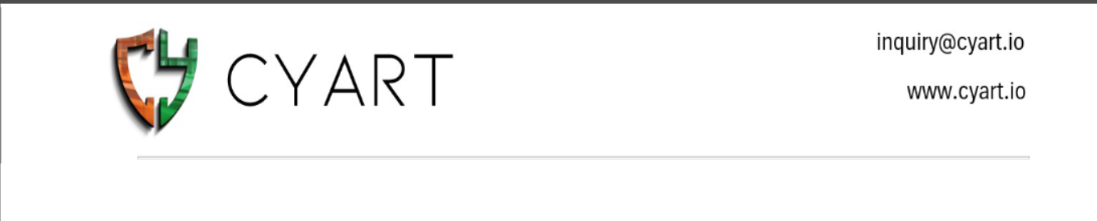
SUBJECT- urgent – escalation – critical ransom ware alert on server X
TO- tier 2 incident response team
FROM – NAVYA YADAV (SOC ANALYST)

Dear Tier 2 Security Team,
A critical security alert has been identified on Server-X indicating potential ransom ware activity. During initial investigation, a suspicious executable file crypto_locker.exe was detected along with unusual network communication from IP address 192.168.1.50. These indicators suggest possible malicious activity and unauthorized system access.
As an immediate containment step, the affected server has been isolated from the network to prevent further spread. Relevant system logs and arti facts have been preserved for forensic analysis. Further investigation is required to determine the root cause, scope of impact, and appropriate remediation actions.
Please review this incident at the earliest and assist with deeper analysis and mitigation.
Regards,
Navya yadav
SOC Analyst

